INSTITUCION EDUCATIVA DEPTAL GUSTAVO URIBE RAMIREZ
GRANADA CUNDINAMARCA AÑO 2022
NIVELACION INGLES 2022
DOCENTE: IRENE AMAYA DOMINGUEZ | AREA, ASIGNATURA Y/0 DIMENSIÓN: INGLES
GRADO: ONCE | FECHA ELABORACION Y ENTREGA AL ESTUDIANTE  OCTUBRE 2022
COMPETENCIA(S) NO ALCANZADA(S) | DESCRIPCION DE ACTIVIDADES A DESARROLLLAR
Solicita y proporciona información sobre experiencias y planes de manera clara y breve Reconoce información específica en textos breves orales y escritos sobre temas de interés general.  Identifica el propósito de textos orales y escritos de mediana longitud relacionados con temas de interés general y de su entorno académico y la comparte con otros textos sugeridos  Emplea tiempos verbales simples y compuestos para escribir, leer y narrar experiencias personales o historias conocidad | Función de la lengua.  -vocabulario y gramática: en la actividad encontrará, una caja de vocabulario que le servirá para resolverlas, es necesario que revise sus apuntes y haga uso del diccionario.  -textos discontinuos: debe observar y analizar de forma detallada las imágenes, leer y comprender las instrucciones y luego responder a preguntas, o unir, describir, etc.  Comprensión lectora: primero debe leer el texto en inglés, hacer un reconocimiento global de la lectura, es decir, comprender el tema el vocabulario, el tiempo verbal etc., enseguida soluciona las actividades propuestas. En caso de tener dificultades haga uso diccionario  Apropiación de la lengua, aprendizaje y dominio de la lengua, en contexto.
CRITERIOS DE EVALIUACIO  1.Solo se recibirán actividades en las fechas asignadas  Se deben entregar todas las actividades resueltas.  La parte escrita tiene un valor de 50%  4. la sustentación 50 % | FUENTES BIBLIOGRÁFICAS https://www.colombiaaprende.edu.co/recurso-coleccion/way-go-para-  https://www.eltbase.com/mats/Escape-from-the-canyon.pdf
ANEXOS (Guías – Talleres)
FECHA DE ENTREGA  Octubre 04 | FECHA DE ENTREGA DE EVIDENCIAS  OCTUBRE 18 de 2022 sustentación en a partir de el 19 de octubre
ESTUDIANTE | VALORACIÓN DOCENTE
Revisado Coordinación académica Maria Lucy Gutierrez
DIRECT AND REPORTED SPEECH
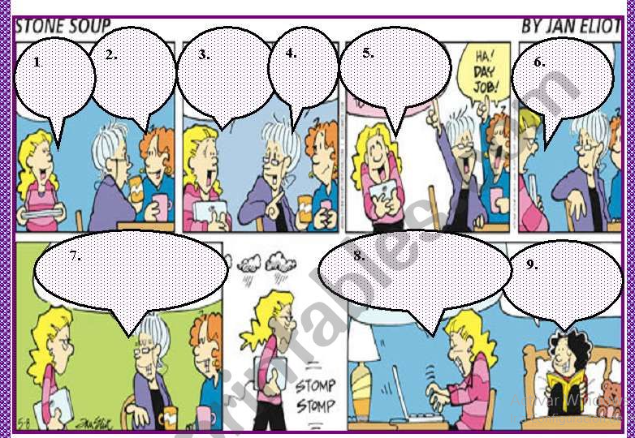

Exercice 2.

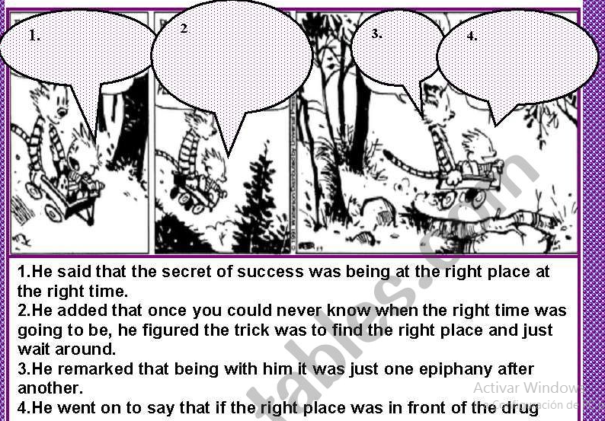

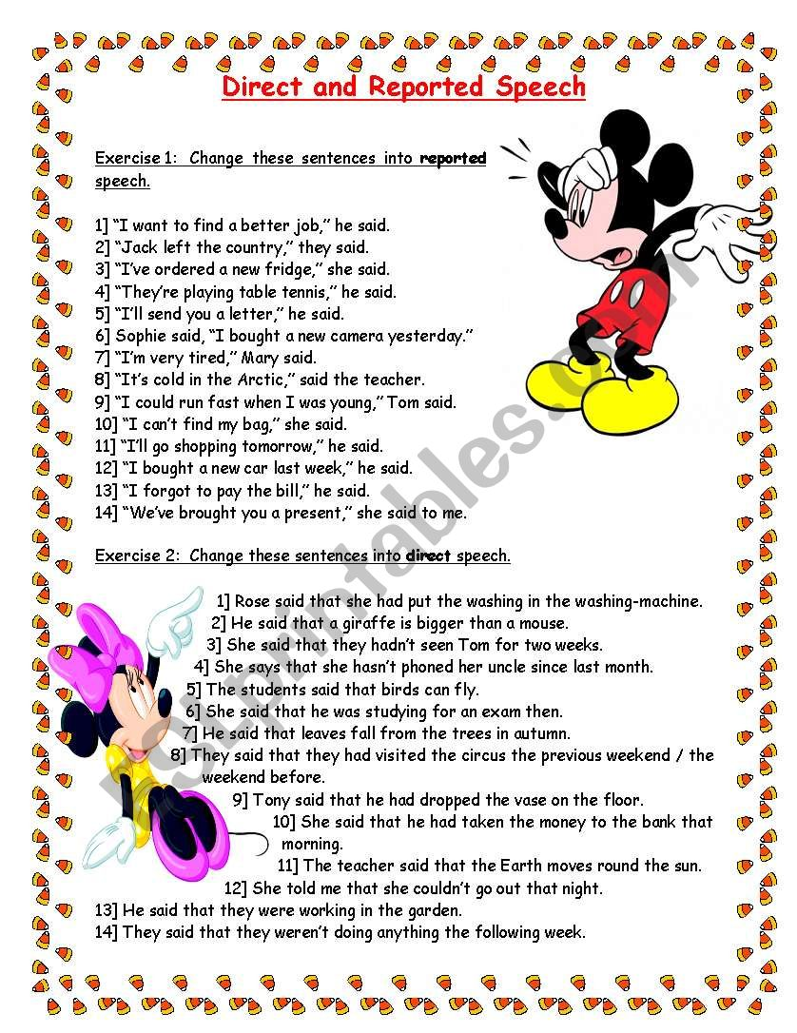

the active to the passive voice

3.2 Actividades de contextualización e identificación de conocimientos necesarios para el aprendizaje.
Now have your students change these sentences from the active to the passive omitting the original subject.
A.Christopher Columbus discovered America in 1492.
B.My mom baked a cake for my birthday.
C,Our mail carrier brought the mail to the front door.
D.The librarian always recommends great books.
E.Janie plays cards with a full deck.

1_______________________________________
2_________________________________________
3_____________________________________
4______________________________________
5_________________________________________
3. did the two football fans steal the car?
A. No, they didn’t
B. Yes, they did
C. Not mentioned

4.Who was the car taken by?
A. By the wife of the owner of the caR
B. By the owner of the car
C. By the owner of the car
5. Did the suspects accept the 5000 dollars?
A. No, they didn’t.
B. Not mentioned
C. Yes, they did
Vocabulary
- By any chance:expresión que significa de casualidad o por causalidad
- Recipe: receta
- Miracle: milagro
- Reputed: renombrado o renombrada

Carl: What’s the name of the song you’re listening to?
Ximena: It’s called The End
Carl: By any chance, do you know who composed it?
Ximena: Well, it (1) ________ composed by my uncle.
Carl: Really? I didn’t know that. He is very talented.
Ximena: Actually, my family is quite talented.
Carl: Yeah? Why do you say that?
Ximena: Well, the famous recipe Muffin Paella was (2) ________ by my grandfather.
Carl: I love Muffin Paella.
Ximena: All the books in the saga called Realistic Miracles (3) ________ by my father.
Carl: I thought that saga (4) ________ written by Charles Dickens
Ximena: No, it wasn’t.
Carl: What about you Ximena? Have you created or written something?
Ximena: No, I’d like to direct a movie but I don’t think I am as talented as the rest of my family.
Carl: I am sure you’ll become a reputed movie director and several movies (5) ________ you.

1. A. was B. were C. did
2. A. invent B. invnted. C. inventing
3. A.was written B.were written C. did written
4. A.been B.had was C.had been
5. A.will be directed by B.is being directed for C. is going be directed with

Seleccione la respuesta correcta.
1. the chef cooks food every day.
A.Food was cooked every day by the chef
B. Food is cooked every day by the chef
C.Food were cooked every day by the chef
2. The dog ate my dinner
A.My dinner were eaten by the dog
B.My dinner is eaten by the dog
C.My dinner was eaten by the dog
OBJECT PRONOUNS WITH THE PASSIVE
3. She sent an email.
An email was sent by…………………..
4. We solved the problem.
The problem was solved……………………
5. I closed the door.
The door was closed ... .……………….
6. He caught the thief.
The thief was caught ... …………………….

RUBRICA DE EVALUACION:
 |  | Very well 5.0 | Quite well 4.0 | With difficulty 3.0- 1.0
VOCABUARY | I can identify vocabulary
GRAMMAR | I can use Wh questions  I can use the verbs passive or passive
READING | I understand texts of diferents topics
writing | I can write about diferents topics
Listening | I can identifity information in short conversations voice active and passive

Relative Clauses - Formation
Complete the sentences using relative clauses. Use who and which.
- A Scot is a person (live in Scotland) …………………………………………….
- Nessie is a monster (live in Loch Ness)…………………………………….
- A fridge is a thing (keep food cool) …………………………………………
- A DJ is someone (play music in a disco)…………………………………………….
- A bee is an insect (make honey)…………………………………………………….
- A lemon is a fruit (be yellow and sour)……………………………………………
- A watch is a thing (tell the time)………………………………………………………
- A ferry is a ship (carry people across the water)……………………………………
- A shop assistant is someone (work in a shop) ……………………………………..
- A key is a thing (can open and lock doors ………………………………………..

Relative Pronouns (who / which / whose)
Choose the correct relative pronoun (who, which, whose).
- This is the bank was robbed yesterday.
- A boy sister is in my class was in the bank at that time.
- The man robbed the bank had two pistols.
- He wore a mask made him look like Mickey Mouse.
- He came with a friend waited outside in the car.
- The woman gave him the money was young.

- The bag contained the money was yellow.
- The people were in the bank were very frightened.
- A man mobile was ringing did not know what to do.
- A woman daughter was crying tried to calm her.
- The car the bank robbers escaped in was orange.
- The robber mask was obviously too big didn't drive.
- The man drove the car was nervous.
- He didn't wait at the traffic lights were red.
- A police officer car was parked at the next corner stopped and arrested them.

READING COMPREHENSION

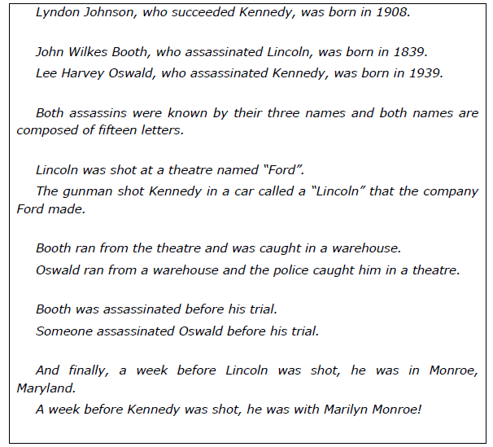

How good is your memory? Answer the following questions without looking
back at the previous text.
1. On which day of the week were both presidents killed?
.
2. Who killed Kennedy?
.
3. What was the name of the presidents that succeeded both Kennedy and Lincoln?
.
4. Where was Lincoln a week before his death?
.
5. Who was born in 1908?
.
6. When was Kennedy elected?
.
7. Where was Lincoln shot?
.
8. What issue were both presidents involved with?
.
Grammar practice. Rewrite the following text using the passive voice where
possible. Remove all references to the agent.
Examples: I poured the mixture into the test tube.
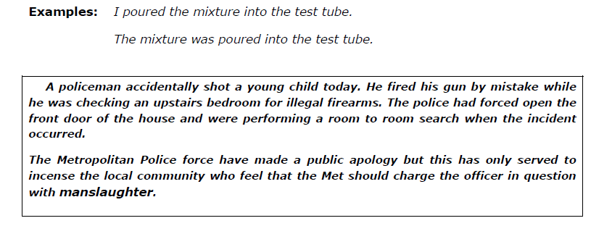
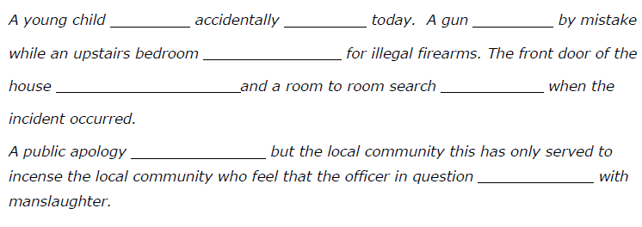

  - Actividades de evaluación Sustentación oral 40% y escrita 60% riterio

4. RECURSOS PARA EL APRENDIZAJE

5 GLOSARIO DE TÉRMINOS
Consultar en el diccionario las palabras desconocidas y escríbelos en tu cuaderno
6. BIBLIOGRAFÍA; cuaderno de apuntes, libro guía

RUBRICA DE EVALUACION:
 |  | Very well 5.0 | Quite well 4.0 | With difficulty 3.0- 1.0
VOCABUARY | I can identify vocabulary
GRAMMAR | I can use Wh questions  I can use the verbs passive or passive
READING | I understand texts of diferents topics
writing | I can write about diferents topics
Listening | I can identifity information in short conversations voice active and passive

